Входное тестирование, 11 класс

1.

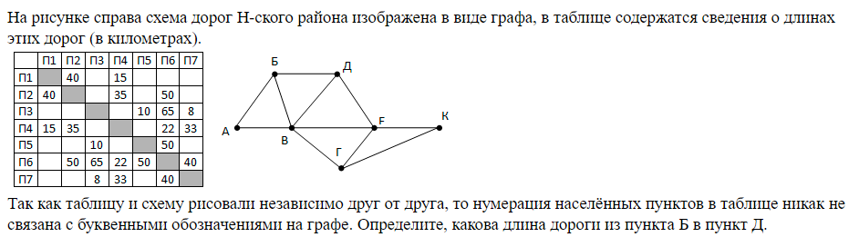

2.

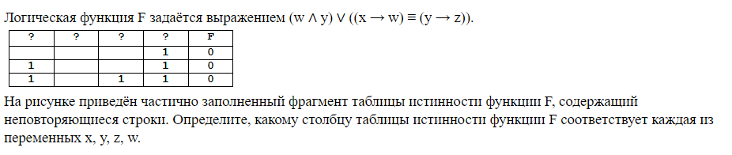

3.

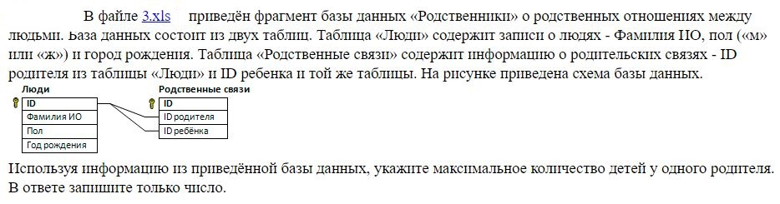

4.

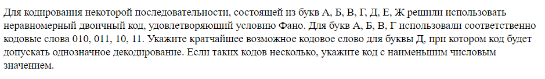

5.

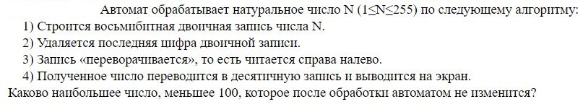

6.

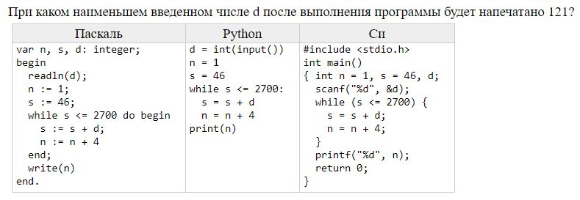

7.

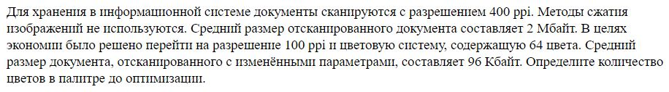

8.



9.

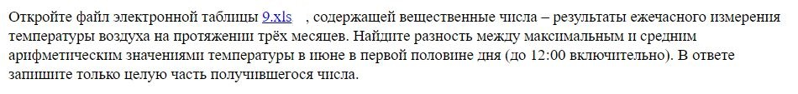

10.



11.

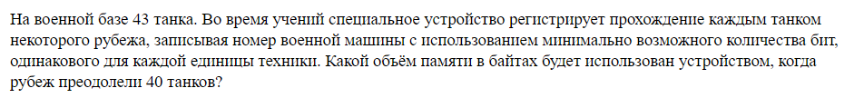

12.

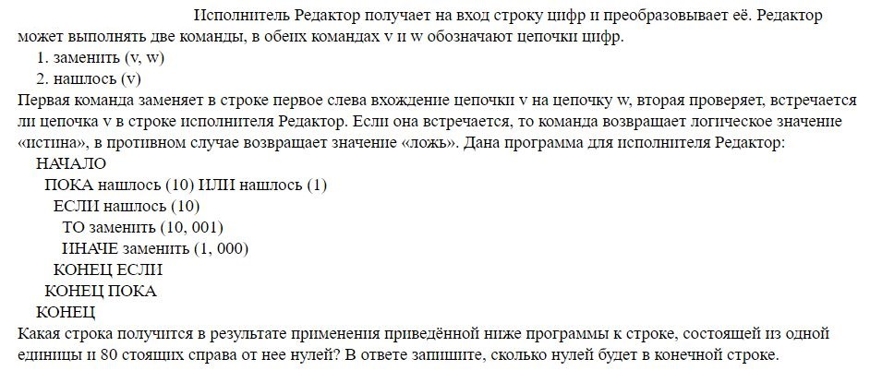

13.

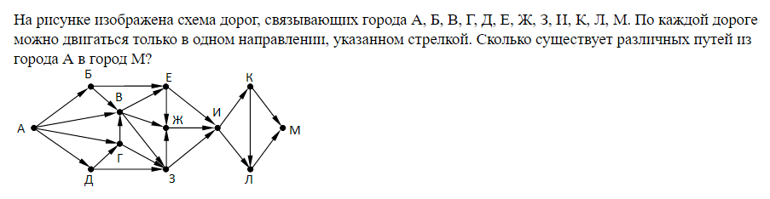

14.



15.

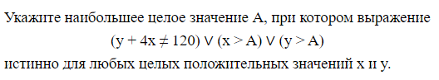

16.

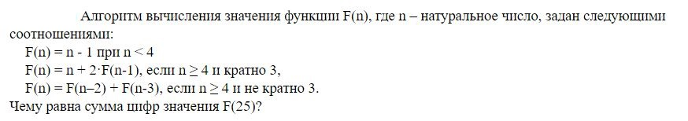

17.

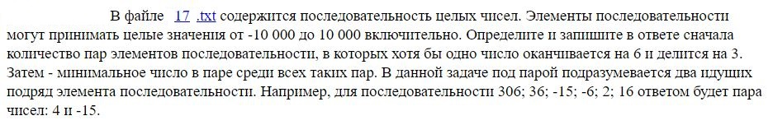

18.

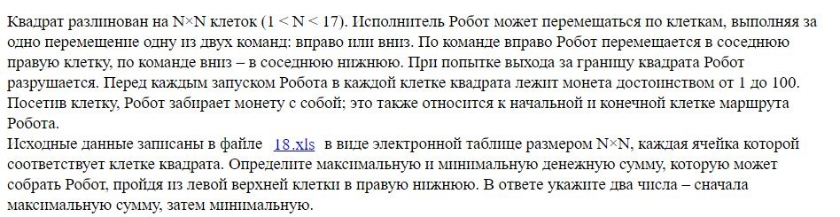

19 – 21.

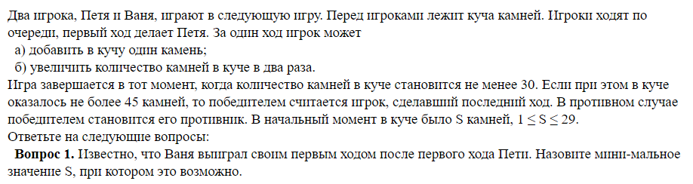

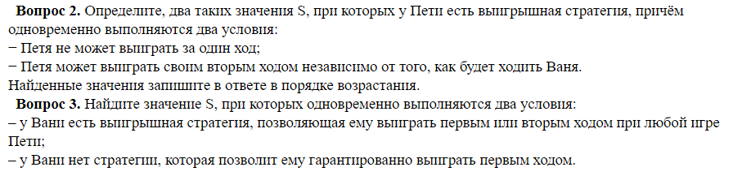

22.

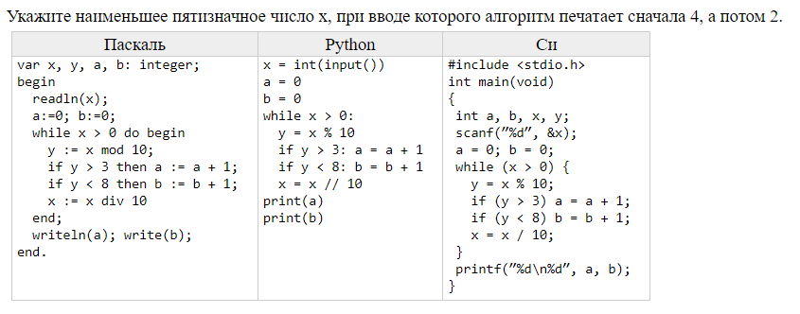

23.

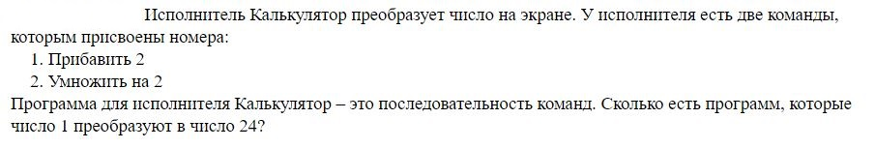

24.

C:\Users\nifon\Desktop\24.JPG

25.



Ответы

|  |  |  |  |  |  |
| --- | --- | --- | --- | --- | --- |
| 1 |  |  | 14 |  |  |
| 2 |  |  | 15 |  |  |
| 3 |  |  | 16 |  |  |
| 4 |  |  | 17 |  |  |
| 5 |  |  | 18 |  |  |
| 6 |  |  | 19 |  |  |
| 7 |  |  | 20 |  |  |
| 8 |  |  | 21 |  |  |
| 9 |  |  | 22 |  |  |
| 10 |  |  | 23 |  |  |
| 11 |  |  | 24 |  |  |
| 12 |  |  | 25 |  |  |
| 13 |  |  |  |  |  |